# **Bike Store Sales Analysis**

### **1. Introduction**

The purpose of this analysis is to provide insights into bike sales across various stores, customer behaviour, staff performance, and product trends. By leveraging data from multiple sources, we aim to identify key drivers of sales, store performance, customer preferences, and product demand to guide strategic decision-making.

### **2. Data Preprocessing**

#### **Objective:**

The goal of the preprocessing phase was to clean and prepare the data for analysis. We used **SQL** to remove missing data, standardise date formats, and perform basic data cleaning. Additionally, we used **Power Query** to create new columns, merge data, and remove duplicates. These steps ensured the dataset was accurate, consistent, and ready for further analysis.

#### **Tasks Performed:**

1. **Removing Null Values Using SQL**:
   * We identified and removed rows with missing (null) data in important fields like customer details, prices, and order dates. This ensured that all the data used in the analysis was complete and reliable.
2. **Changing Date Formats Using SQL**:
   * We standardised the date formats in the dataset to ensure consistency when analysing trends over time. This step made it easier to work with time-based data, such as monthly or yearly sales trends.
3. **Using Power Query for Advanced Data Cleaning**:
   * **Creating New Columns**: We added new columns to the dataset, such as calculating the total revenue for each order by multiplying the price and quantity.
   * **Merging Columns**: We merged certain columns to simplify the data. For example, we combined first and last names into a single column for easier reference.
   * **Removing Duplicates**: We used Power Query to remove duplicate records in the dataset, ensuring that no entries were counted twice in the analysis.
4. **Data Validation**:
   * After cleaning the data, we checked that all missing data was removed, dates were correctly formatted, and duplicates were eliminated. This ensured the dataset was ready for the next phase of analysis.

#### **Deliverables:**

* A **cleaned and structured dataset** with:
  + No missing or null values.
  + Consistent date formats.
  + New and merged columns for easier analysis.
  + All duplicate records removed, ensuring accuracy.

### **3. Analysis Questions**

### **Objective:**

This phase focused on formulating key analysis questions that could provide actionable insights into the business.

#### **Key Questions and Insights:**

* **Sales Overview**:
  + **Question**: What is the overall sales performance of the business?
    - **Insight**: The total sales amounted to **7.69M**, with the highest revenue generated from the state of **NY (67.83%)**.
    - **Visualization**: Total sales by category, top purchased products, and sales trend over time (Line chart).
* **Customer Analysis**:
  + **Question**: Who are the top customers, and where are they located?
    - **Insight**: The top customer is **Sharyn Hopkins**, with sales of **~35K**. Most customers are from **Mount Vernon** and **Ballston Spa**.
    - **Visualization**: Top 10 customers by total sales, count of customers by city, and customer order trends.
* **Store Analysis**:
  + **Question**: Which stores generate the most revenue, and how do they differ in terms of sales?
    - **Insight**: **Baldwin Bikes** leads in both revenue and the number of orders, contributing **5.22M** in sales.
    - **Visualization**: Sum of revenue by store, count of orders by store, and product sales by store.
* **Staff Performance**:
  + **Question**: Which staff members are driving the most sales and handling the highest volume of orders?
    - **Insight**: **Marcelene Boyer** leads with the highest revenue and the most orders processed.
    - **Visualization**: Sum of revenue by staff, count of orders by staff, and quantity sold by staff.
* **Product Analysis**:
  + **Question**: What are the most and least popular products sold?
    - **Insight**: The **Trek Slash 9.7** and **Trek Conduit+** are the top-selling products, while the **Trek Precalber 16 Boy’s** has the lowest sales.
    - **Visualization**: Top 10 and bottom 10 products by sales, stock levels, and sales quantity.
* **Trend Analysis**:
  + **Question**: How do sales trends evolve over time
  + **Insight**: Sales peak during **2018**
    - **Visualization**: Sales trend by order date, average revenue, and product category breakdown.

#### **Deliverables:**

* A comprehensive set of analysis questions with answers derived from the data.

### **Visualization Dashboard and Final Presentation**

#### **Deliverables:**

A fully interactive **Power BI dashboard** covering the key areas of sales, customers, staff, stores, products, and trends.

### **1. Sales Overview Dashboard**

#### **Key Insights:**

* **Total Sales**: The business has generated a total revenue of **7.69M**, which is significant. This overall sales figure serves as a strong baseline for evaluating the performance of products, stores, and staff.
* **Top 5 Purchased Products**: The **Trek Slash 9.7** (27.5 - 2016) is the top-selling product, followed by **Trek Conduit+** and **Trek Fuel EX 8**.
  + **Insight**: The dominance of the **Trek** brand suggests that this brand is a key driver of sales, and continued focus on promoting Trek products could yield further growth.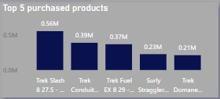
* **Revenue by State**:
  + **Texas (TX)** contributes **67.83%** of total revenue, making it the most important state for sales. **California (CA)** and **Nevada (NV)** follow with smaller contributions.
  + **Insight**: With Texas contributing the bulk of sales, regional marketing efforts should focus on maintaining and growing this market. Expanding operations in Texas could also be considered.

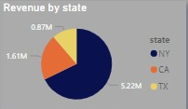

* **Sales by Category**: **Mountain Bikes** lead the category sales with **1.7M**, followed by **Road Bikes**.
  + **Insight**: Mountain Bikes are clearly the most popular category. This trend should inform inventory planning, product promotions, and marketing efforts.

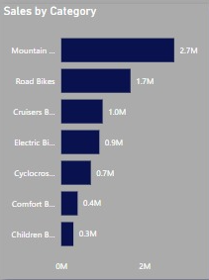

#### **Recommendations:**

* **Focus on Texas**: Since Texas generates the majority of sales, consider local promotions, partnerships, or marketing campaigns tailored to customers in Texas.
* **Trek Brand Promotion**: Highlight Trek products, which are the most popular among customers. Future promotions or discounts could focus on Trek bikes.
* **Increase Inventory for Mountain Bikes**: The popularity of Mountain Bikes indicates that sufficient stock levels should be maintained to meet the ongoing demand.

### 

### **2. Customer Analysis Dashboard**

#### **Key Insights:**

* **Customer Distribution by City**: The highest concentration of customers is in **Mount Vernon**, followed by **Ballston Spa** and **Scottsdale**.
  + **Insight**: These cities represent the largest customer bases and should be the focus of future customer retention programs, such as targeted marketing or loyalty programs.

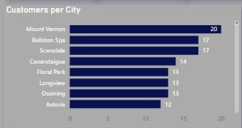

* **Top Customers by Average Sales**:

**Hae Ramirez** leads with an average purchase of over **$10K** per transaction, followed by **Marilyn Frank** and **Ester Acevedo**.

* + **Insight**: High-value customers like **Hae Ramirez** should be prioritized for personalized offers, VIP programs, or exclusive discounts to encourage further spending.

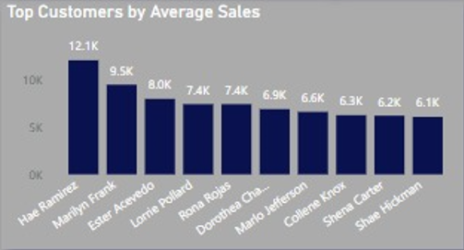

* **Top Customers by Total Sales**:

**Sharyn Hopkins** is the top customer by total sales, contributing the most to overall revenue.

* + **Insight**: Retaining top customers should be a priority as they contribute significantly to the bottom line. Consider creating a special rewards or loyalty program to incentivize repeat purchases.

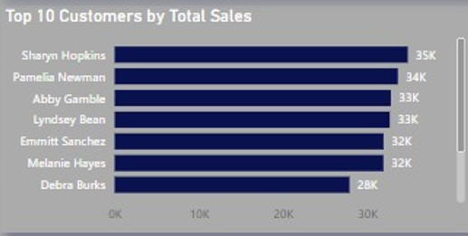

#### **Recommendations:**

* **City-Specific Campaigns**: Develop targeted campaigns for customers in **Mount Vernon**, **Ballston Spa**, and **Scottsdale** to increase retention and customer lifetime value.
* **VIP Programs for High-Value Customers**: Offer exclusive deals or early access to new products for top spenders like **Hae Ramirez** and **Sharyn Hopkins**. Personalized offers can further boost loyalty.
* **Customer Segmentation**: Segment customers by purchase patterns or geographic location to tailor marketing efforts more effectively.

### **3. Store Analysis Dashboard**

#### **Key Insights:**

* **Revenue by Store**:

**Baldwin Bikes** is the top-performing store, generating **5.22M** in revenue, followed by **Santa Cruz Bikes** and **Rowlett Bikes**.

* + **Insight**: Baldwin Bikes accounts for the bulk of total sales, meaning that any issues or improvements made to this store could significantly impact overall business performance.

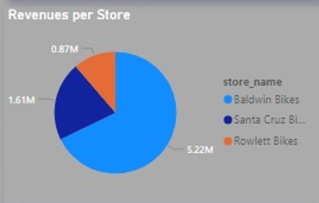

* **Orders by Store**: **Baldwin Bikes** has processed the highest number of orders, with **Santa Cruz Bikes** and **Rowlett Bikes** following behind.
  + **Insight**: Baldwin Bikes appears to be managing a large customer base and high sales volume. This could imply that Baldwin Bikes needs extra attention for staffing, inventory, and customer service.

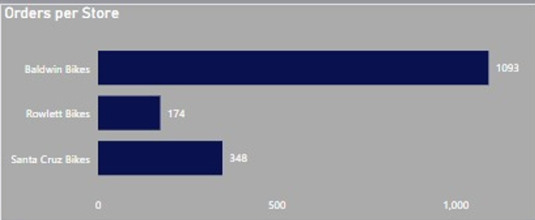

#### **Recommendations:**

* **Optimize Operations at Baldwin Bikes**: Given that Baldwin Bikes is the top-performing store, it’s critical to ensure that operations, staffing, and inventory levels are optimized to meet the demand.
* **Tailor Inventory per Store**: Based on the product distribution, each store appears to specialize in different brands. Tailoring inventory to the specific demands of each store can help reduce stockouts and maximize sales potential.
* **Expand Best Practices**: Since Baldwin Bikes is performing well, consider analyzing their processes and implementing their best practices at other stores to boost overall performance.

### **4. Staff Performance Dashboard**

#### **Key Insights:**

* **Top Performers by Revenue**: **Venita Daniel** generated the highest revenue, followed by **Marcelene Boyer** and **Genna Serrano**. **Venita Daniel** has significantly outperformed other staff members.

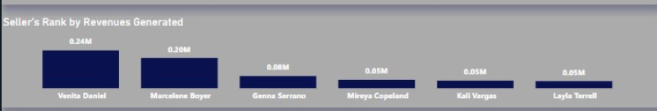

* + **Insight**: Venita Daniel’s performance suggests that she may have strong customer service or upselling skills. Recognizing her performance could incentivize other staff to follow suit.
* **Number of Orders by Staff**: **Venita Daniel** processed the highest number of orders, with Marcelene Boyer following behind.

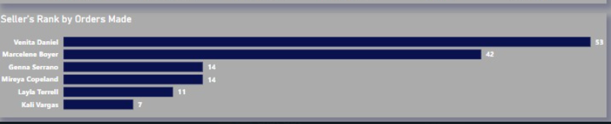

* + **Insight**: **Venita Daniel** not only generates the most revenue but also handles the highest volume of orders, making her a key staff member.
* **Staff Quantity of Items Sold**: The sum of the quantity of items sold by each staff member shows that **Venita Daniel** is also very effective in selling larger quantities, following Marcelene Boyer.
  + **Insight**: While Marcelene Boyer leads overall, Venita Daniel also shows strong potential in terms of sales volume. Training other staff members to adopt similar sales techniques could boost their performance.

#### **Recommendations:**

* **Incentivize High Performers**: Staff members like Marcelene Boyer and Venita Daniel should be rewarded for their performance, possibly through commission structures, bonuses, or public recognition.
* **Offer Upselling Training**: Based on the performance of top staff members, consider providing additional upselling and customer service training for lower-performing staff.
* **Analyse and Replicate Best Practices**: Identify what makes Marcelene and Venita successful in terms of customer interaction or sales techniques, and standardise these practices across all staff members.

### **5. Product Analysis Dashboard**

#### **Key Insights:**

* **Top 10 Products Sold**: The **Trek Slash 8**  is the best-selling product, followed by **Trek Conduit+**. These products significantly contribute to overall revenue.
  + **Insight**: The dominance of the Trek brand in the top-selling products suggests that focusing marketing campaigns on Trek bikes could further boost sales.

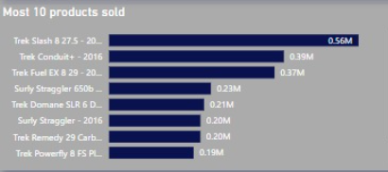

* **Least 10 Products Sold**: Products like **Trek MT 201** and **Electra Cruiser 1** are among the least popular products, generating the least revenue.
  + **Insight**: Consider discontinuing underperforming products or offering discounts to move slow-selling stock and free up inventory space.

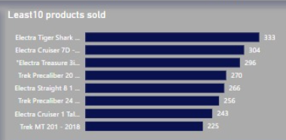

* **Stock Levels vs. Sales**: Some products, such as **Electra Townie Original**, have sufficient stock but lower sales, indicating that demand may not be aligned with inventory levels.
  + **Insight**: Inventory management needs to be optimized to ensure that fast-selling products are well-stocked, while slower-moving products may need promotions to clear them.

#### **Recommendations:**

* **Focus Marketing on Top Products**: Highlight Trek products in promotions and marketing materials to capitalize on their strong sales performance.
* **Clear Slow-Moving Inventory**: Consider discounting or bundling the slowest-selling products to move inventory and make room for higher-demand items.
* **Monitor Stock Levels Closely**: Ensure that the highest-demand products, such as the Trek Slash 9.7, are adequately stocked to prevent potential stockouts.

### **6. Trend Analysis Dashboard**

#### **Key Insights:**

* **Sales Over Time**: The sales trend over time shows a significant spike in **mid-2018**, followed by a steady performance. Sales have been largely stable but show potential for growth during peak seasons.
  + **Insight**: Sales peak around certain periods, likely due to seasonal demand. It’s important to plan for these spikes by increasing inventory and staffing during busy months.

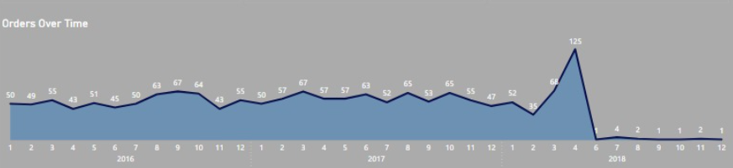

#### **Recommendations:**

* **Seasonal Promotions**: Plan promotional activities leading up to peak sales periods to maximize revenue.
* **Prepare for Demand Spikes**: Ensure adequate stock levels and staff availability during known sales spikes, such as summer months and holiday seasons.

### **6. Conclusion and Recommendations**

#### **Key Insights:**

1. **Product Focus**: **Mountain Bikes** and **Road bikes** are the leading products. Marketing efforts should prioritize these products.
2. **Customer Retention**: Top customers contribute significantly to total sales. Offering loyalty programs or personalized offers may increase retention.
3. **Store Optimization**: **Baldwin Bikes** is outperforming other stores. Sharing best practices across stores could improve performance.
4. **Staff Efficiency**: **Venita Daniel** stands out as the top-performing staff member. Incentive programs could be rolled out to recognize top performers.

#### **Next Steps:**

* **Actionable Recommendations**: Increase stock for high-demand products, improve inventory management, and focus marketing efforts on top customers and products.
* **Future Forecasting**: Monitor predicted sales and product trends to ensure adequate staffing and inventory management in the upcoming months.